**Application Behavior:**

Here are my points about the application features regarding the assignment

1. In the Home screen(MainActivity) fetching the list of Pupils from the given endpoint using Retrofit service client library for fetching data as it gives some benefits.
2. Getting the list of Pupil for the first time and inserting the pupilList in SQlite Database and populating it to the UI using Recycler view as below

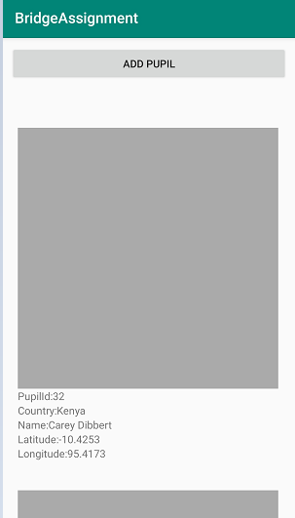

1. Loading the image from the imageURl after fetching the pupil details by making a service call asynchronously in the background.
2. As of now fetching only one image from the asynchronous call as it is taking more time to fetch original image.

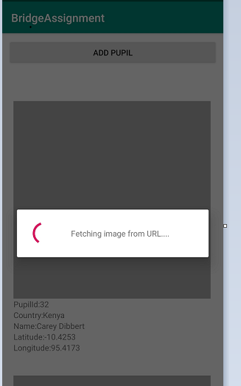

1. If network connection is not there then showing a text with no pupil to display.

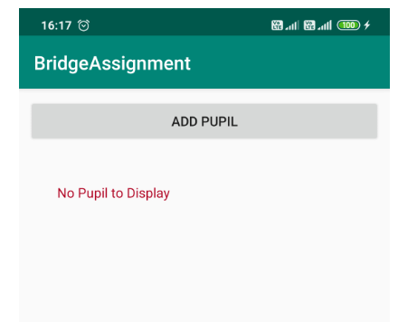

6.If the user turns on the data in this screen, then make the service call to get the Pupil list and again do the same process.

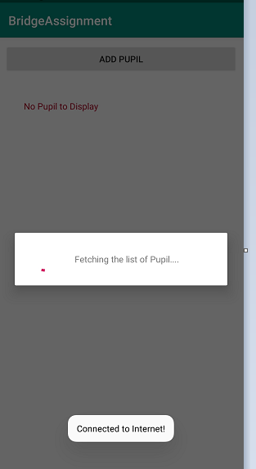

7. I have placed a button “Add Pupil” in the Home screen, whenever user clicks on the button, navigating user to AddPupil screen

8. Below is the screen to add a new pupil.

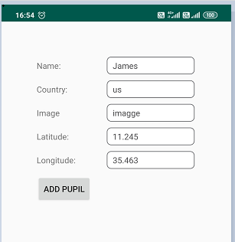

9. After filling the necessary details and clicking the Add Pupil button will post the details to server using the respective add pupil endpoint using Retrofit

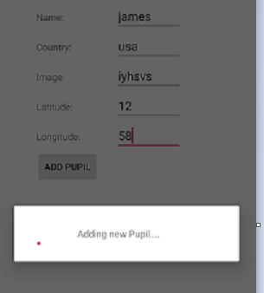

10. If user doesn’t fill all the details then showing validation message like “ Please fill all Details” to the user

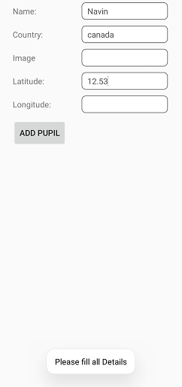

11. If network connection is not there, while adding new people, saving the new pupil details in the local Sqlite database and returning the user to Home Screen.

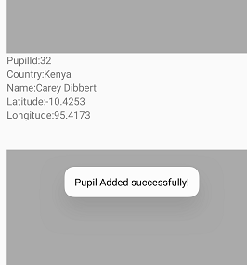

12. As mentioned above you can get the pupil list and add a new pupil in the application even offline and get the list whenever the Data is connected back.

13. Due to Time constraints I have not yet implemented the Unit test cases.

**App.gradle Versions:**

CompileSDKVersion 29

buildToolsVersion 29.0.2

minSDKVersion 15

targetSDKVersion 29

**Dependencies Used in the project:**

dependencies {

implementation fileTree(dir: 'libs', include: ['*.jar'])

implementation 'androidx.appcompat:appcompat:1.1.0'

implementation 'androidx.constraintlayout:constraintlayout:1.1.3'

implementation 'com.google.android.material:material:1.1.0'

testImplementation 'junit:junit:4.12'

androidTestImplementation 'androidx.test:runner:1.2.0'

androidTestImplementation 'androidx.test.espresso:espresso-core:3.2.0'

implementation 'com.squareup.retrofit2:retrofit:2.3.0'

implementation 'com.squareup.retrofit2:converter-gson:2.3.0'

implementation 'com.android.support:recyclerview-v7:26.1.0'

**}**